2000_PTR Enrollment initiated by CE - New Move in
Combo
1.Contract No. 4009690592
Material No. 88000105
Serial No. 29101113
Equipment No. 100005155098
Contract Account. 100023406018
Functional Location. 6002276745
2.Contract No. 4009690559
Material No. 80010079
Serial No. 25169178
Equipment No. 100002881783
Contract Account. 100023406018
Functional Location. 6002276760

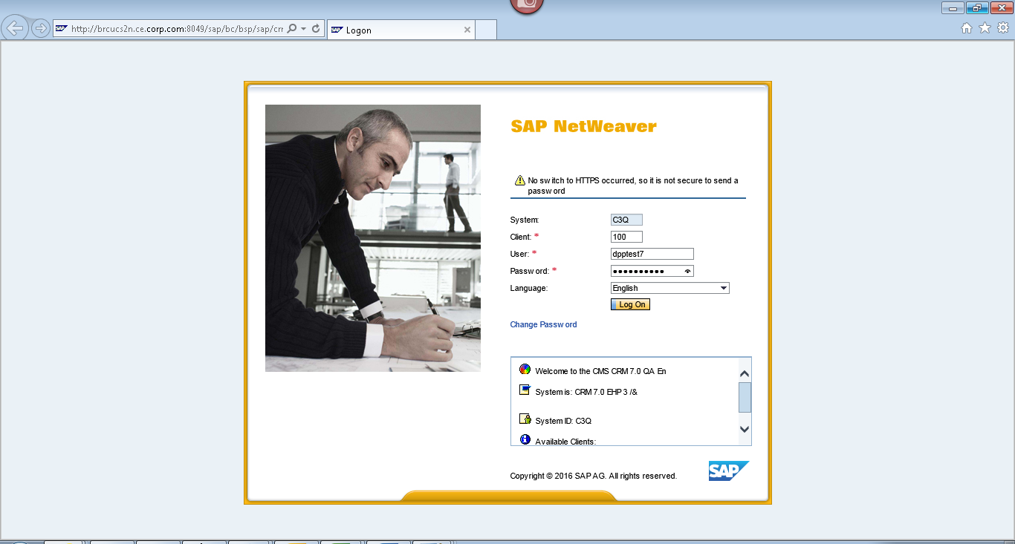
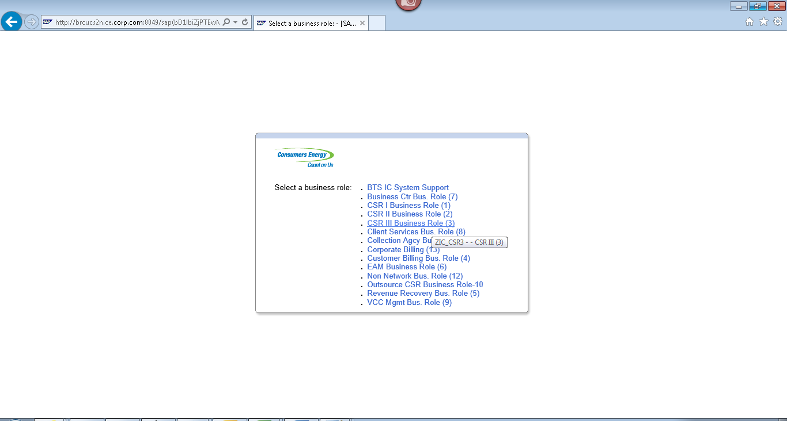
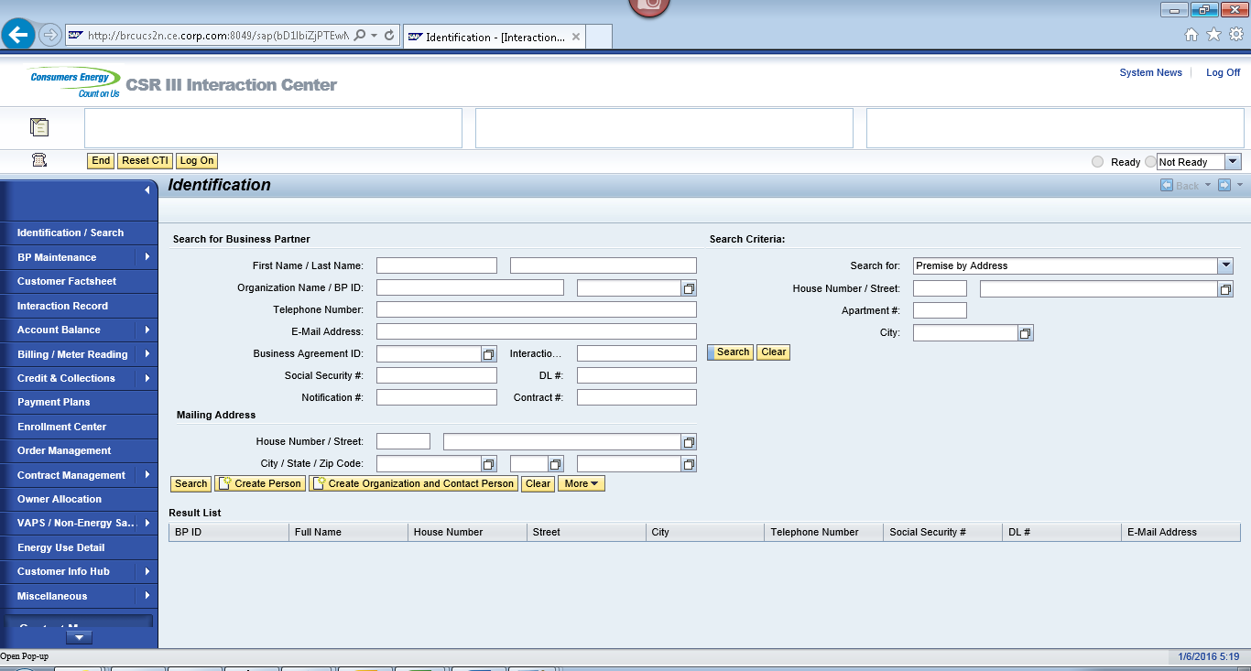
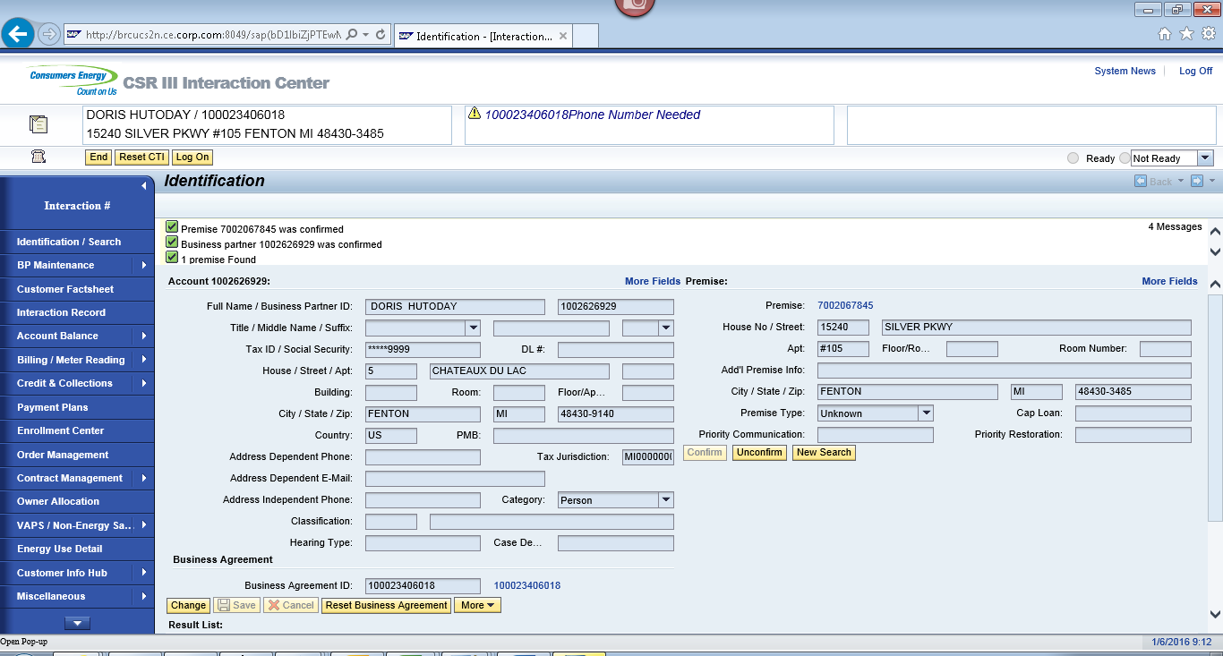
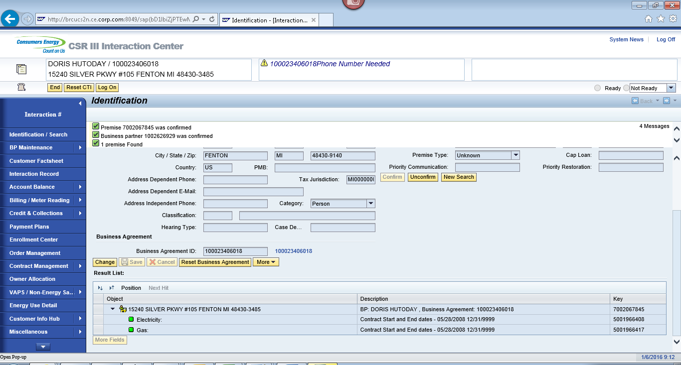
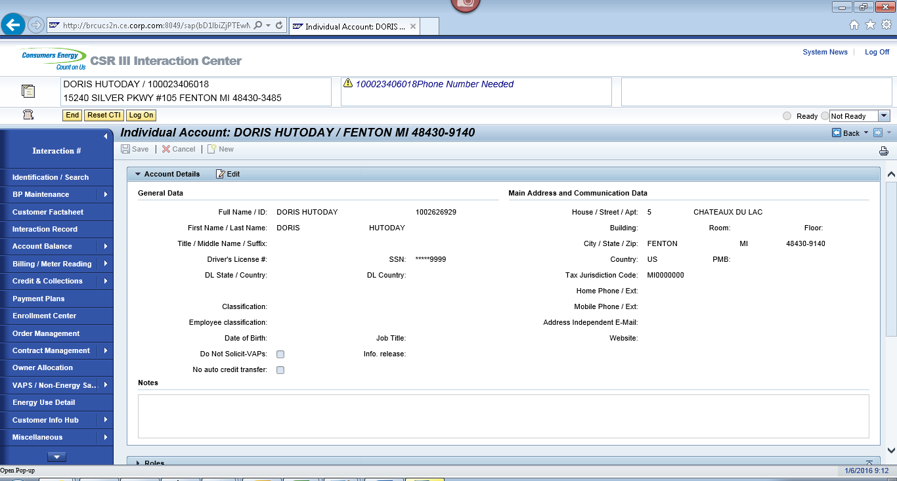
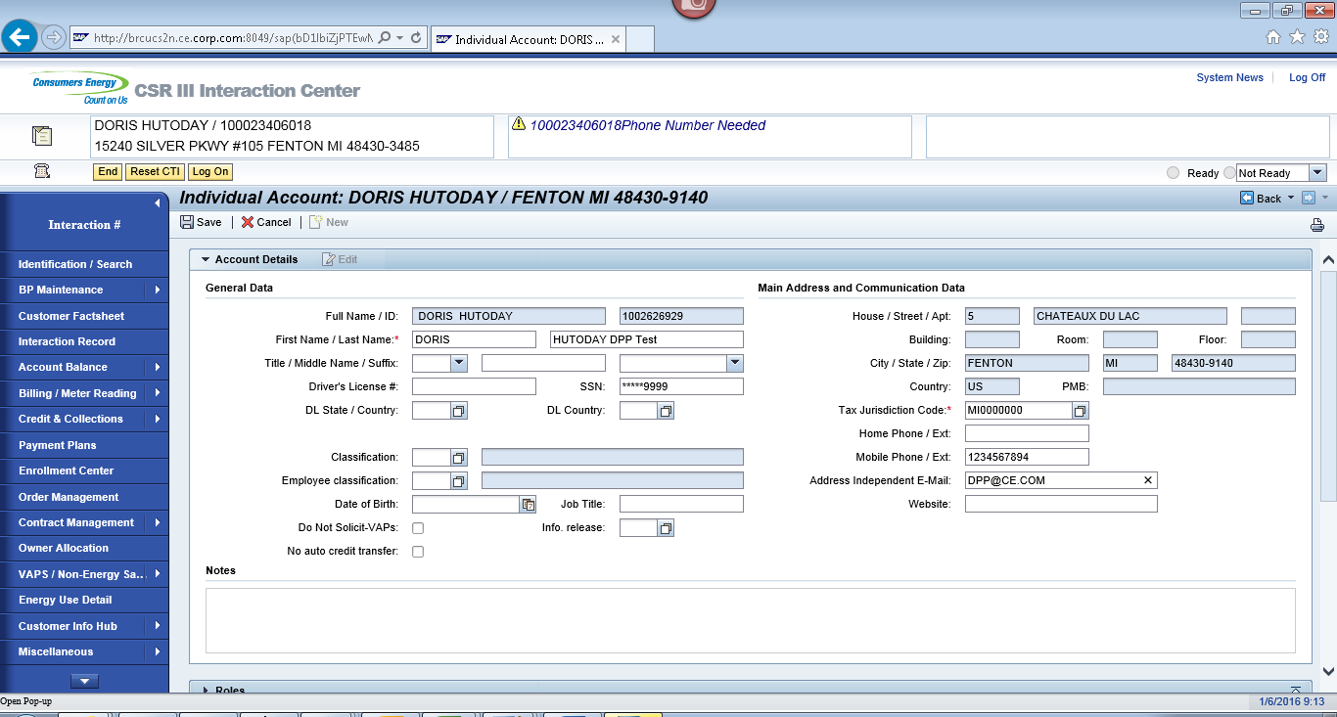
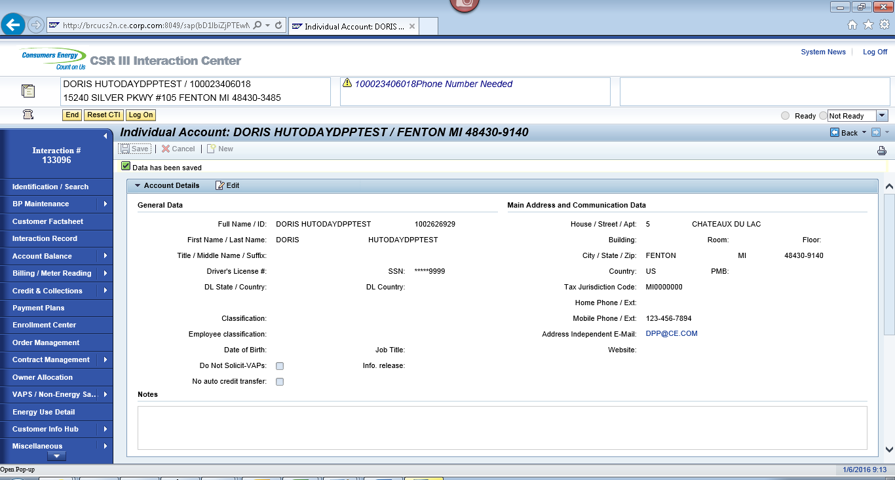

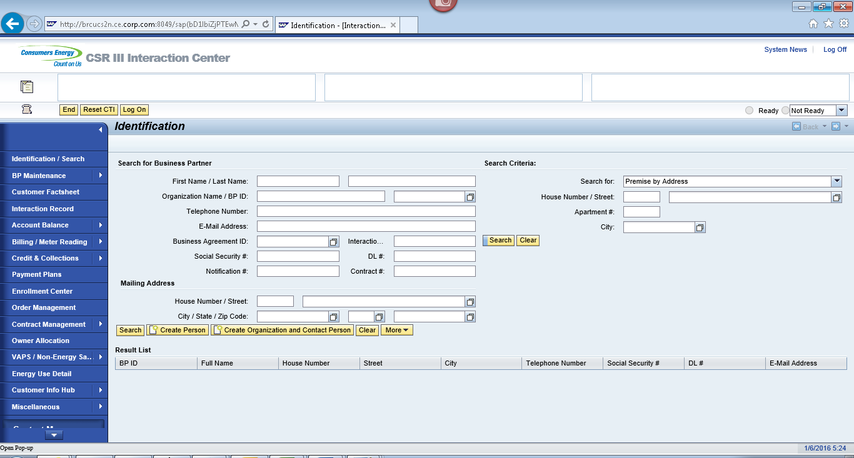
ECC
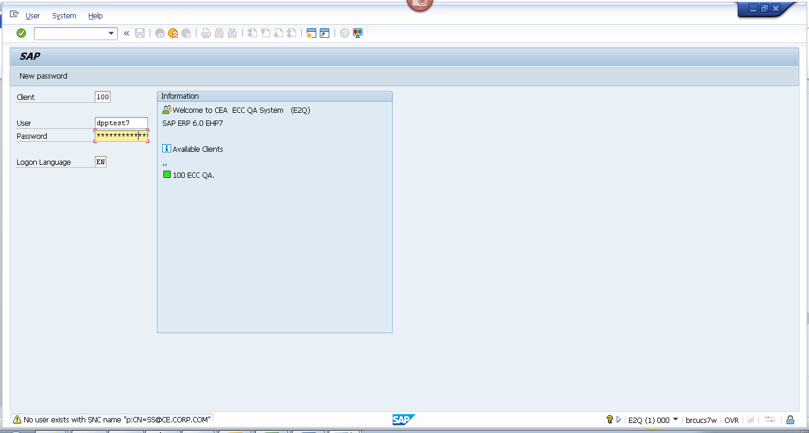
Contract 1
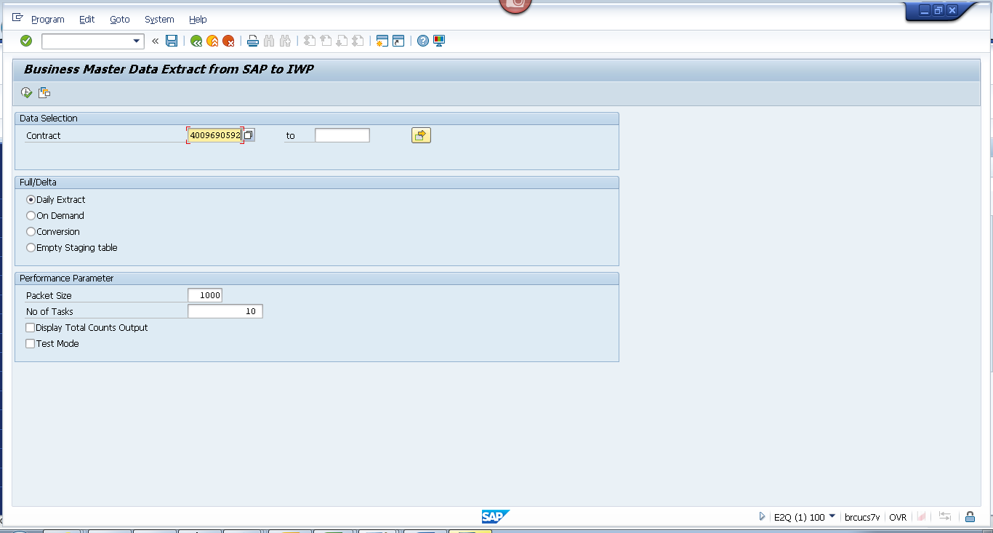
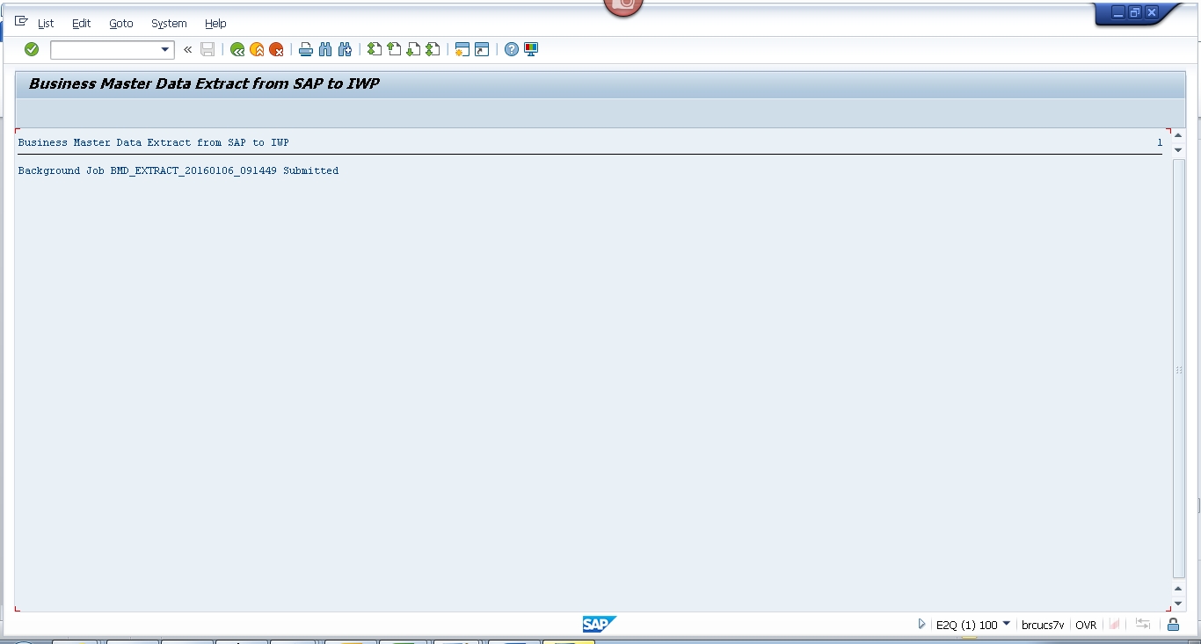Contract 2
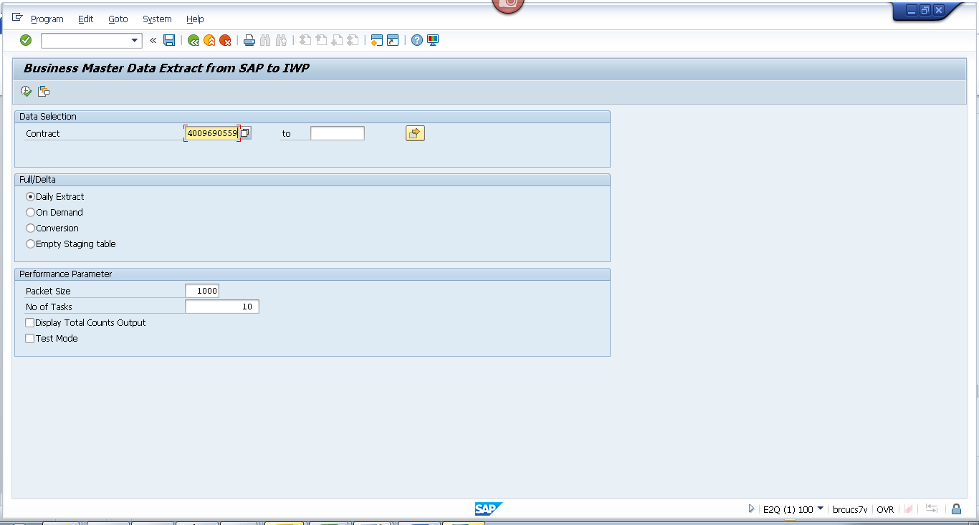
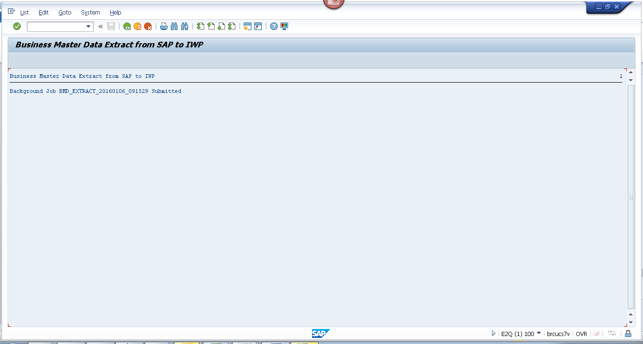

Obj tracking
Contract 1
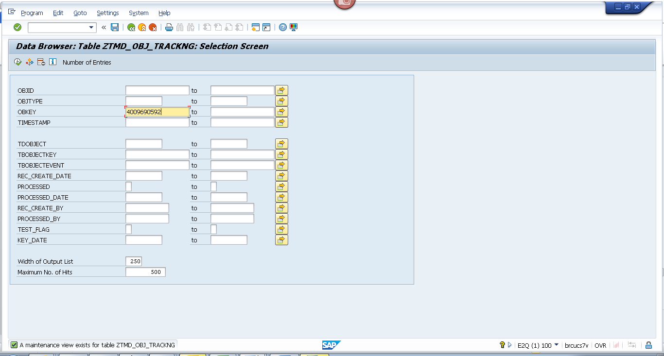
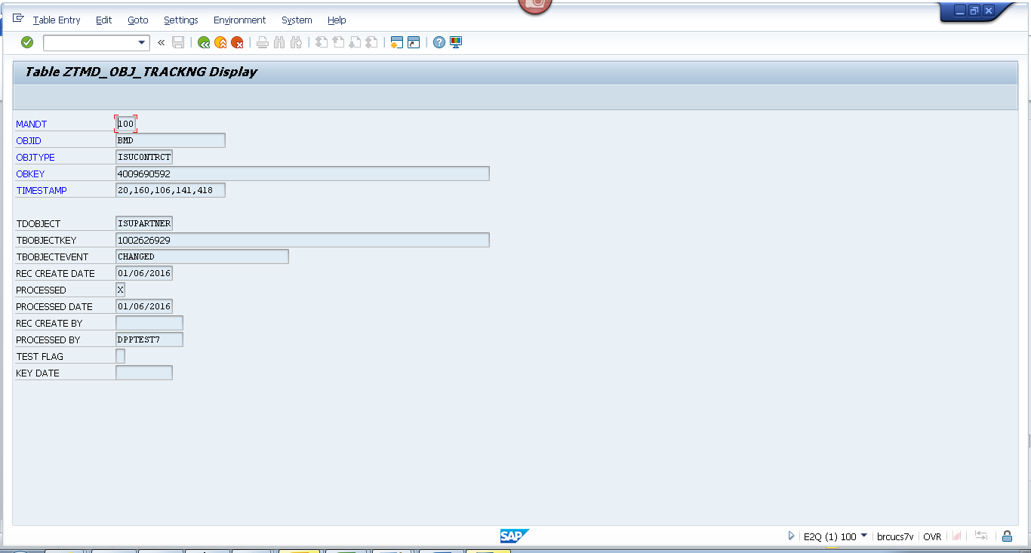
Contract 2
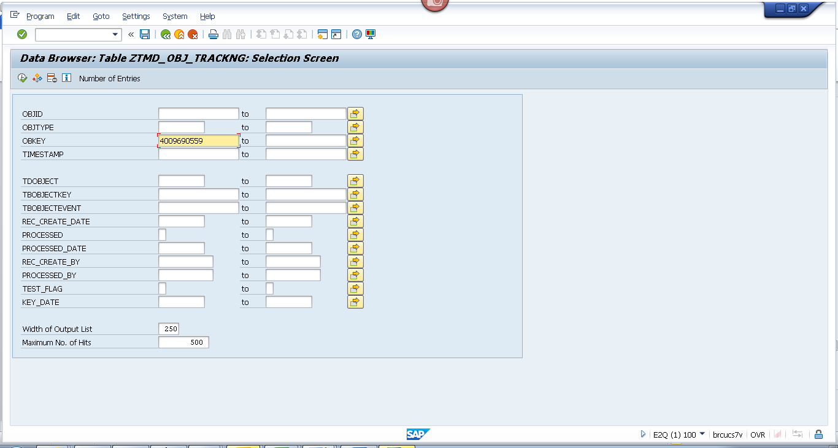
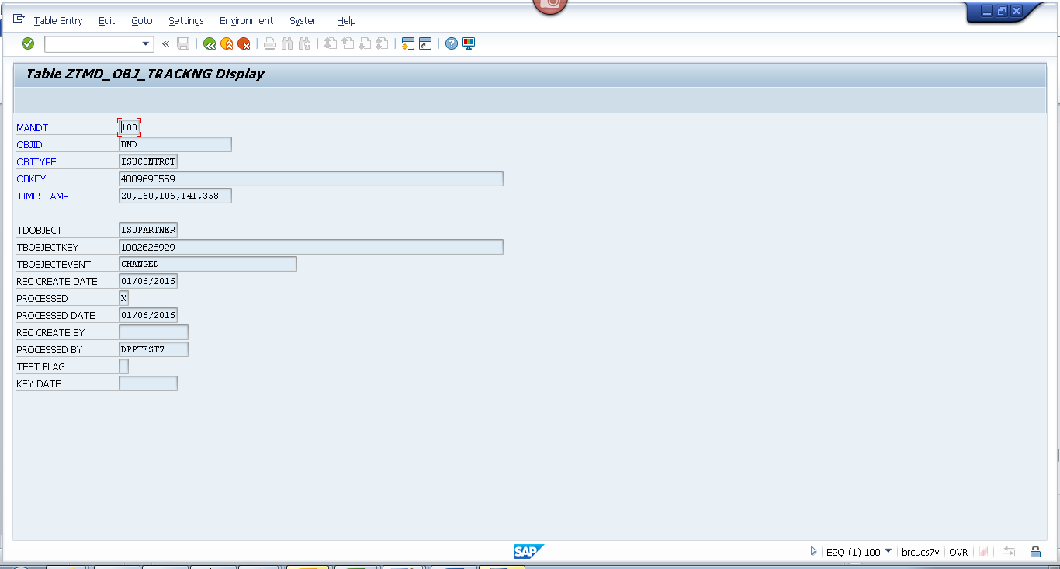

Spool
Contract 1
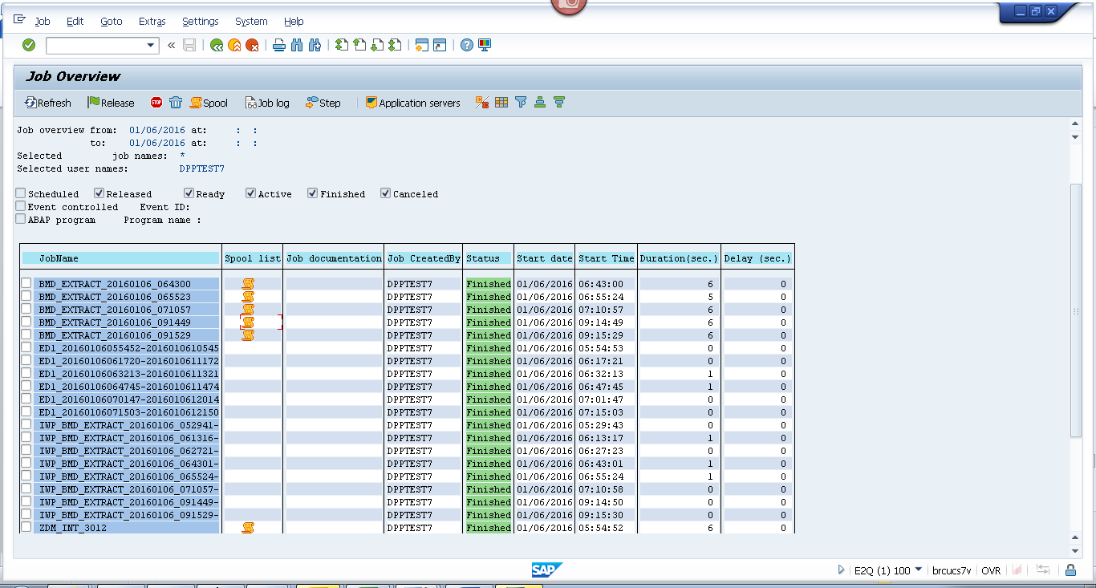
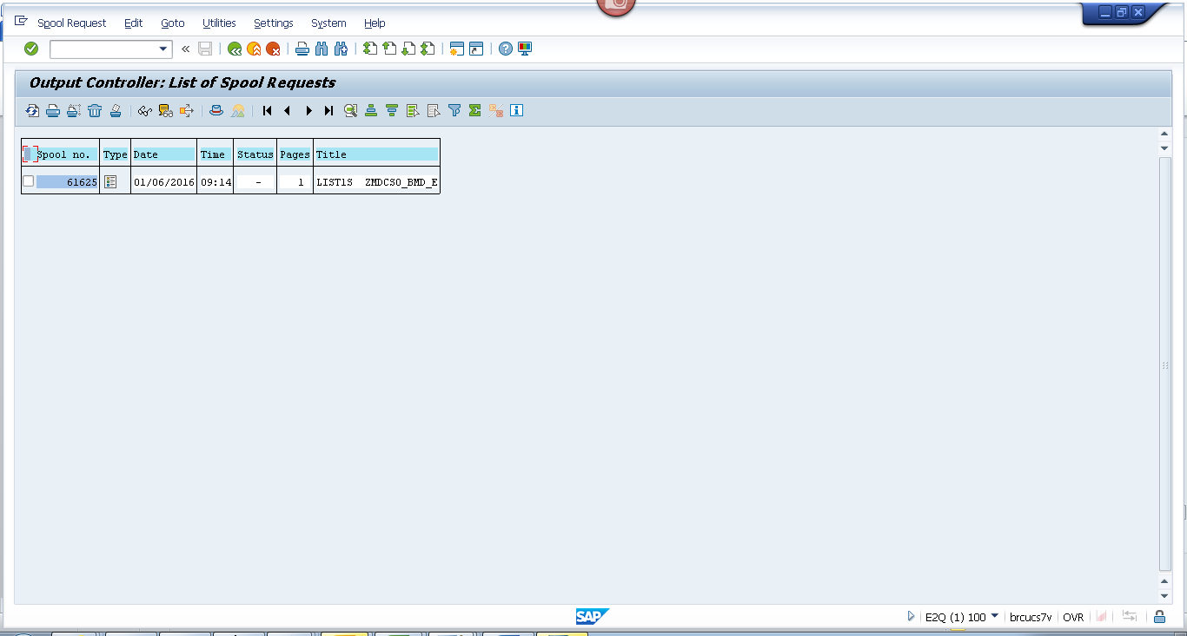
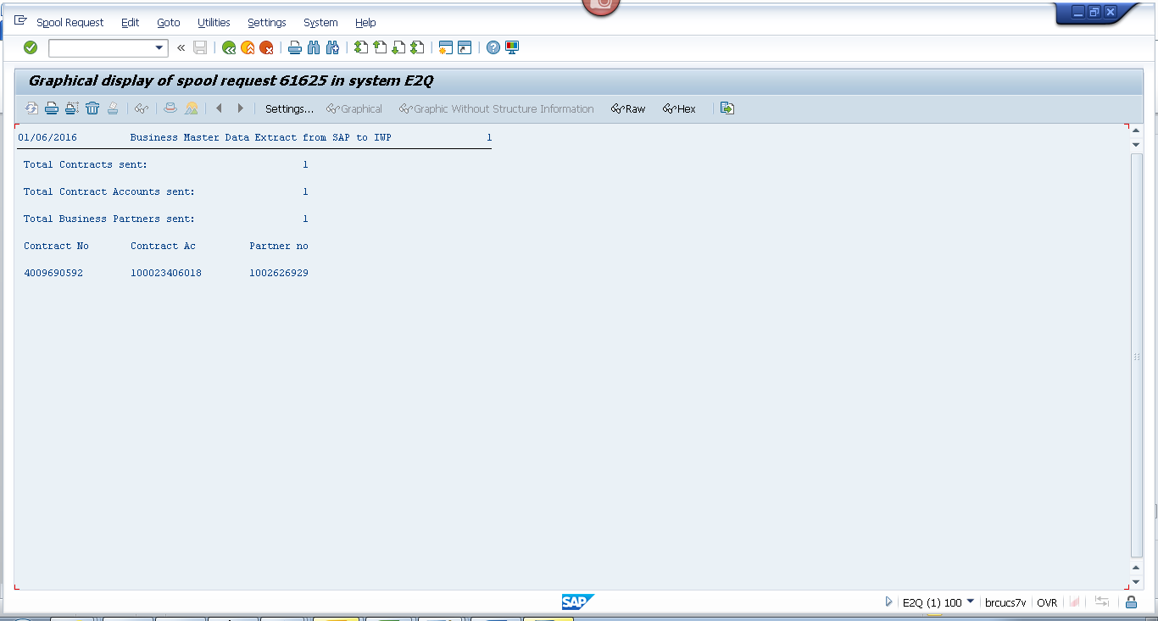Contract 2
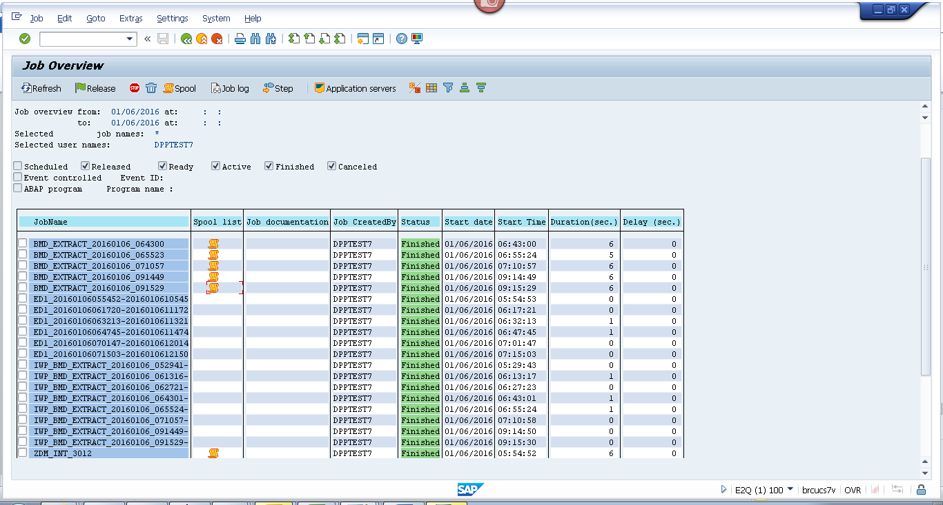
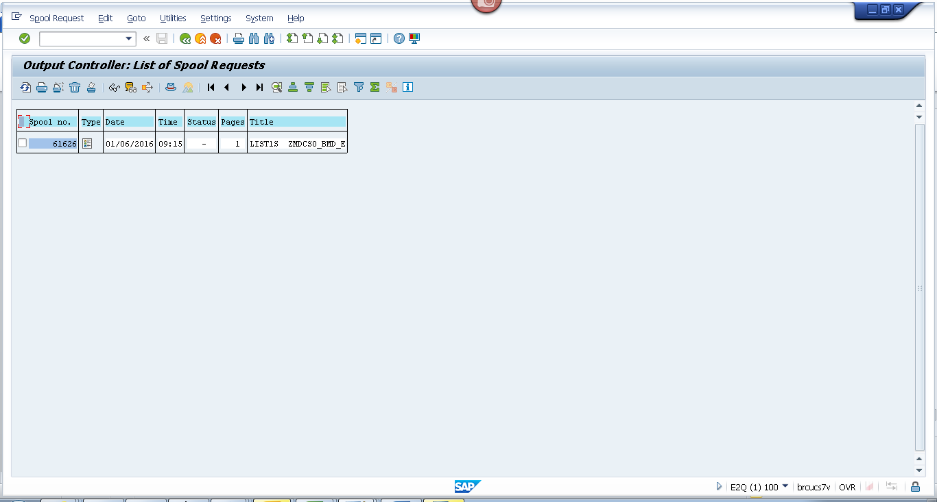
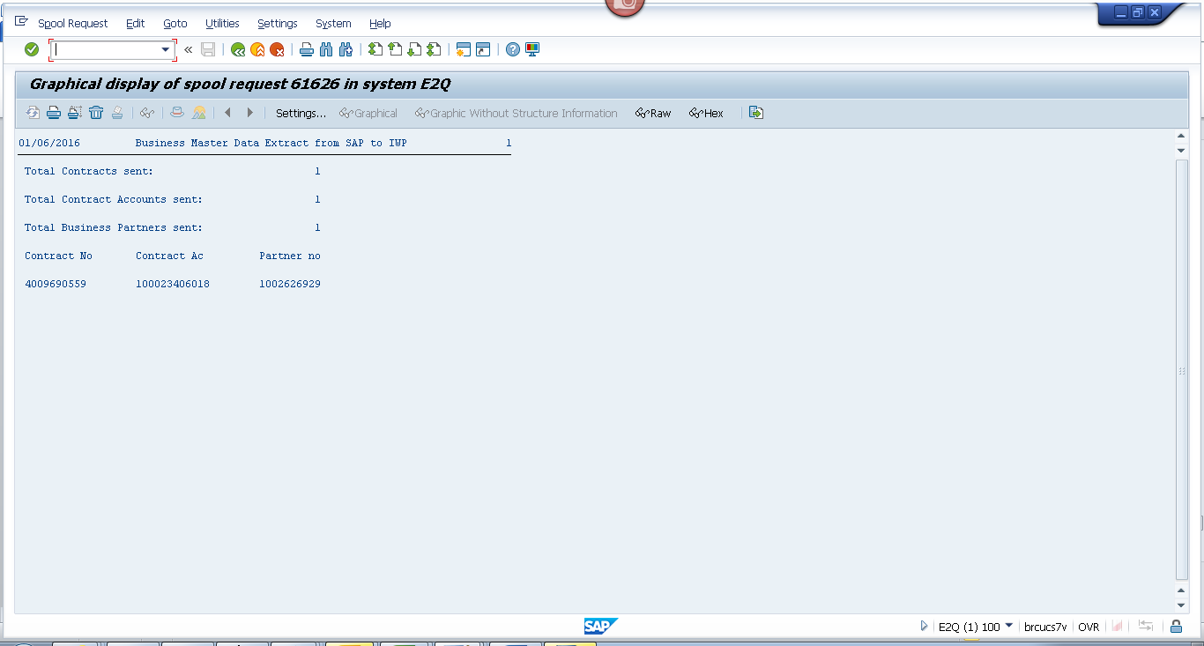

Payload
Contract 1
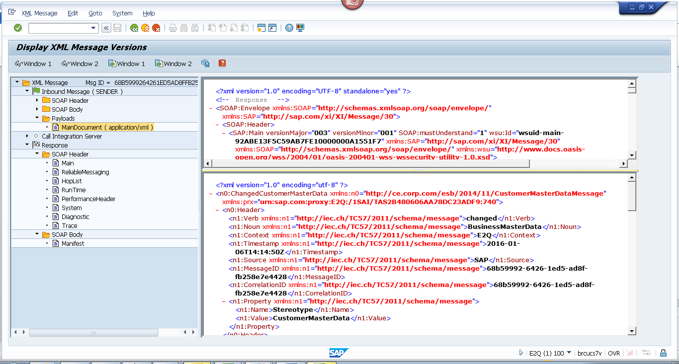
<?xml version="1.0" encoding="utf-8" ?>
- <n0:ChangedCustomerMasterData xmlns:n0="http://ce.corp.com/esb/2014/11/CustomerMasterDataMessage" xmlns:prx="urn:sap.com:proxy:E2Q:/1SAI/TAS2B480606AA78DC23ADF9:740">
- <n0:Header>
<n1:Verb xmlns:n1="http://iec.ch/TC57/2011/schema/message">changed</n1:Verb>
<n1:Noun xmlns:n1="http://iec.ch/TC57/2011/schema/message">BusinessMasterData</n1:Noun>
<n1:Context xmlns:n1="http://iec.ch/TC57/2011/schema/message">E2Q</n1:Context>
<n1:Timestamp xmlns:n1="http://iec.ch/TC57/2011/schema/message">2016-01-06T14:14:50Z</n1:Timestamp>
<n1:Source xmlns:n1="http://iec.ch/TC57/2011/schema/message">SAP</n1:Source>
<n1:MessageID xmlns:n1="http://iec.ch/TC57/2011/schema/message">68b59992-6426-1ed5-ad8f-fb258e7e4428</n1:MessageID>
<n1:CorrelationID xmlns:n1="http://iec.ch/TC57/2011/schema/message">68b59992-6426-1ed5-ad8f-fb258e7e4428</n1:CorrelationID>
- <n1:Property xmlns:n1="http://iec.ch/TC57/2011/schema/message">
<n1:Name>Stereotype</n1:Name>
<n1:Value>CustomerMasterData</n1:Value>
</n1:Property>
</n0:Header>
- <n0:Payload>
- <n2:CustomerMasterData xmlns:n2="http://ce.corp.com/esb/2014/11/CustomerMasterData#">
- <n2:Customer>
<n2:mRID>1002626929</n2:mRID>
<n2:name>DORISHUTODAYDPPTEST</n2:name>
- <n2:CustomerAccounts>
<n2:mRID>100023406018</n2:mRID>
<n2:createdDateTime>2008-06-21T04:00:00Z</n2:createdDateTime>
<n2:paperBill>true</n2:paperBill>
<n2:paymentTerm>CE21</n2:paymentTerm>
<n2:type>RES</n2:type>
- <n2:CustomerAgreements>
<n2:mRID>4009690592</n2:mRID>
<n2:accountDeterminationID>RT</n2:accountDeterminationID>
<n2:createdDateTime>2008-06-22T04:00:00Z</n2:createdDateTime>
<n2:division>ELECTRIC</n2:division>
<n2:rateCategory>RS_1000</n2:rateCategory>
<n2:startMonth>00</n2:startMonth>
- <n2:Installation>
<n2:mRID>5001966408</n2:mRID>
</n2:Installation>
- <n2:ServiceLocations>
- <n2:UsagePoints>
<n2:mRID>6002276745</n2:mRID>
</n2:UsagePoints>
</n2:ServiceLocations>
- <n2:validityInterval>
<n2:end>9999-12-31T23:59:59Z</n2:end>
<n2:start>2008-05-28T00:00:00Z</n2:start>
</n2:validityInterval>
</n2:CustomerAgreements>
</n2:CustomerAccounts>
- <n2:Indicators>
<n2:type>SENIOR</n2:type>
</n2:Indicators>
- <n2:Indicators>
<n2:type>DLA EXCLUSION</n2:type>
</n2:Indicators>
- <n2:Indicators>
<n2:type>DPP EXCLUSION</n2:type>
</n2:Indicators>
- <n2:Indicators>
<n2:type>DO NOT MARKET</n2:type>
</n2:Indicators>
- <n2:MainAddress>
- <n2:streetDetail>
<n2:buildingName>0014064583</n2:buildingName>
<n2:name>CHATEAUX DU LAC</n2:name>
<n2:number>5</n2:number>
</n2:streetDetail>
- <n2:townDetail>
<n2:code>48430-9140</n2:code>
<n2:country>US</n2:country>
<n2:name>FENTON</n2:name>
<n2:stateOrProvince>MI</n2:stateOrProvince>
</n2:townDetail>
</n2:MainAddress>
- <n2:Persons>
<n2:firstName>DORIS</n2:firstName>
<n2:lastName>HUTODAYDPPTEST</n2:lastName>
- <n2:electronicAddress>
<n2:email1>DPP@CE.COM</n2:email1>
</n2:electronicAddress>
- <n2:landlinePhone>
<n2:localNumber>-</n2:localNumber>
</n2:landlinePhone>
- <n2:mobilePhone>
<n2:localNumber>123-456-7894</n2:localNumber>
</n2:mobilePhone>
</n2:Persons>
</n2:Customer>
</n2:CustomerMasterData>
</n0:Payload>
</n0:ChangedCustomerMasterData>

Contract 2
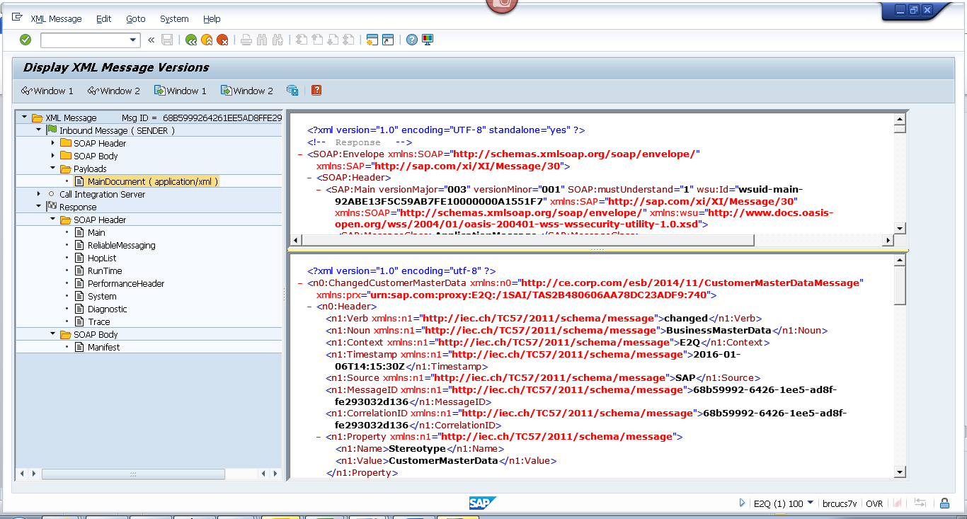

<?xml version="1.0" encoding="utf-8" ?>
- <n0:ChangedCustomerMasterData xmlns:n0="http://ce.corp.com/esb/2014/11/CustomerMasterDataMessage" xmlns:prx="urn:sap.com:proxy:E2Q:/1SAI/TAS2B480606AA78DC23ADF9:740">
- <n0:Header>
<n1:Verb xmlns:n1="http://iec.ch/TC57/2011/schema/message">changed</n1:Verb>
<n1:Noun xmlns:n1="http://iec.ch/TC57/2011/schema/message">BusinessMasterData</n1:Noun>
<n1:Context xmlns:n1="http://iec.ch/TC57/2011/schema/message">E2Q</n1:Context>
<n1:Timestamp xmlns:n1="http://iec.ch/TC57/2011/schema/message">2016-01-06T14:15:30Z</n1:Timestamp>
<n1:Source xmlns:n1="http://iec.ch/TC57/2011/schema/message">SAP</n1:Source>
<n1:MessageID xmlns:n1="http://iec.ch/TC57/2011/schema/message">68b59992-6426-1ee5-ad8f-fe293032d136</n1:MessageID>
<n1:CorrelationID xmlns:n1="http://iec.ch/TC57/2011/schema/message">68b59992-6426-1ee5-ad8f-fe293032d136</n1:CorrelationID>
- <n1:Property xmlns:n1="http://iec.ch/TC57/2011/schema/message">
<n1:Name>Stereotype</n1:Name>
<n1:Value>CustomerMasterData</n1:Value>
</n1:Property>
</n0:Header>
- <n0:Payload>
- <n2:CustomerMasterData xmlns:n2="http://ce.corp.com/esb/2014/11/CustomerMasterData#">
- <n2:Customer>
<n2:mRID>1002626929</n2:mRID>
<n2:name>DORISHUTODAYDPPTEST</n2:name>
- <n2:CustomerAccounts>
<n2:mRID>100023406018</n2:mRID>
<n2:createdDateTime>2008-06-21T04:00:00Z</n2:createdDateTime>
<n2:paperBill>true</n2:paperBill>
<n2:paymentTerm>CE21</n2:paymentTerm>
<n2:type>RES</n2:type>
- <n2:CustomerAgreements>
<n2:mRID>4009690559</n2:mRID>
<n2:accountDeterminationID>RT</n2:accountDeterminationID>
<n2:createdDateTime>2008-06-22T04:00:00Z</n2:createdDateTime>
<n2:division>GAS</n2:division>
<n2:rateCategory>A_250</n2:rateCategory>
<n2:startMonth>00</n2:startMonth>
- <n2:Installation>
<n2:mRID>5001966417</n2:mRID>
</n2:Installation>
- <n2:ServiceLocations>
- <n2:UsagePoints>
<n2:mRID>6002276760</n2:mRID>
</n2:UsagePoints>
</n2:ServiceLocations>
- <n2:validityInterval>
<n2:end>9999-12-31T23:59:59Z</n2:end>
<n2:start>2008-05-28T00:00:00Z</n2:start>
</n2:validityInterval>
</n2:CustomerAgreements>
</n2:CustomerAccounts>
- <n2:Indicators>
<n2:type>SENIOR</n2:type>
</n2:Indicators>
- <n2:Indicators>
<n2:type>DLA EXCLUSION</n2:type>
</n2:Indicators>
- <n2:Indicators>
<n2:type>DPP EXCLUSION</n2:type>
</n2:Indicators>
- <n2:Indicators>
<n2:type>DO NOT MARKET</n2:type>
</n2:Indicators>
- <n2:MainAddress>
- <n2:streetDetail>
<n2:buildingName>0014064583</n2:buildingName>
<n2:name>CHATEAUX DU LAC</n2:name>
<n2:number>5</n2:number>
</n2:streetDetail>
- <n2:townDetail>
<n2:code>48430-9140</n2:code>
<n2:country>US</n2:country>
<n2:name>FENTON</n2:name>
<n2:stateOrProvince>MI</n2:stateOrProvince>
</n2:townDetail>
</n2:MainAddress>
- <n2:Persons>
<n2:firstName>DORIS</n2:firstName>
<n2:lastName>HUTODAYDPPTEST</n2:lastName>
- <n2:electronicAddress>
<n2:email1>DPP@CE.COM</n2:email1>
</n2:electronicAddress>
- <n2:landlinePhone>
<n2:localNumber>-</n2:localNumber>
</n2:landlinePhone>
- <n2:mobilePhone>
<n2:localNumber>123-456-7894</n2:localNumber>
</n2:mobilePhone>
</n2:Persons>
</n2:Customer>
</n2:CustomerMasterData>
</n0:Payload>
</n0:ChangedCustomerMasterData>

